Mike Sharkey – Arizona State Uni

ASU charter of success has a nice line about inclusivity

We can put data in front of students to help them do their job better

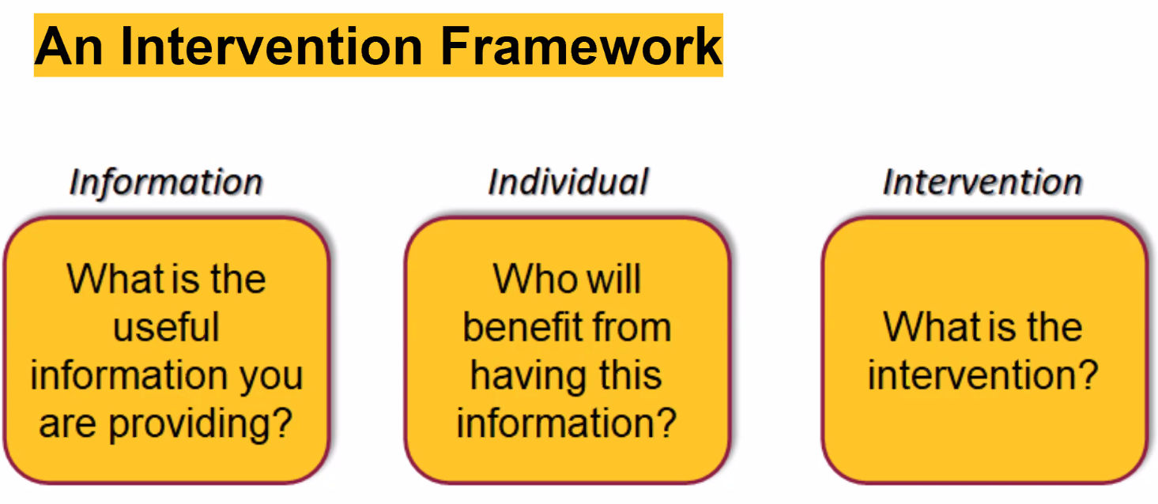

Title of dashboard will be a question (i.e. which of your students are at risk?)

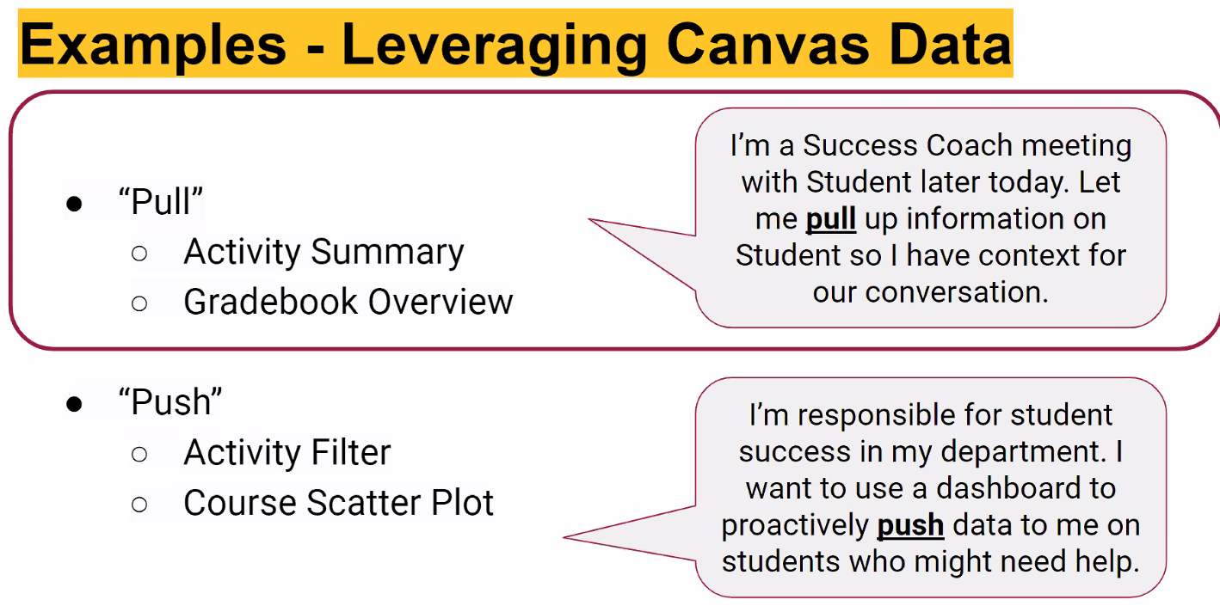

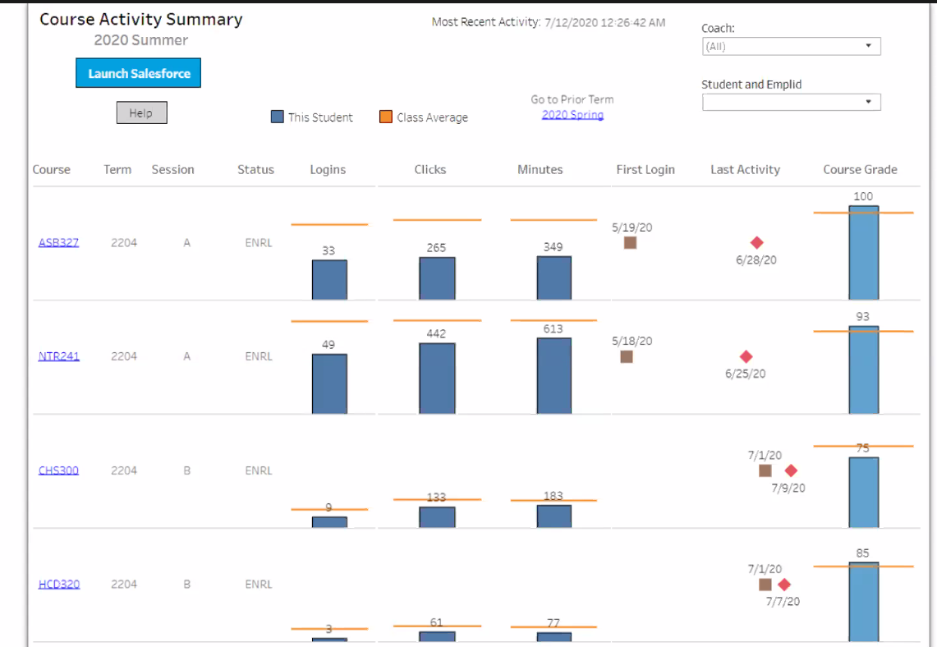

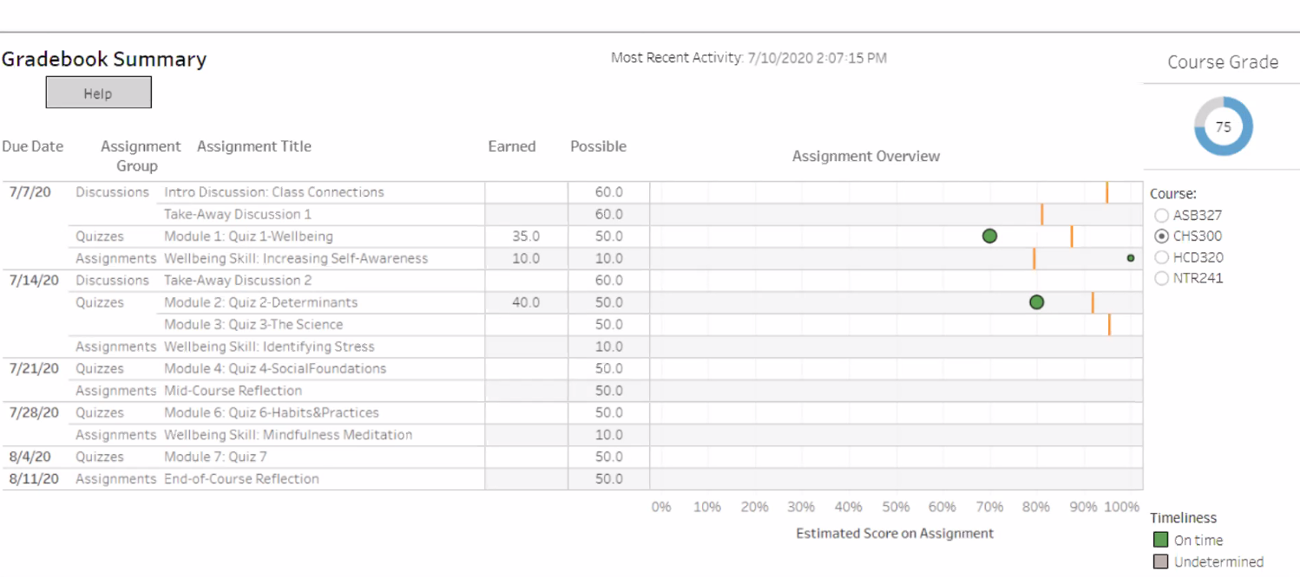

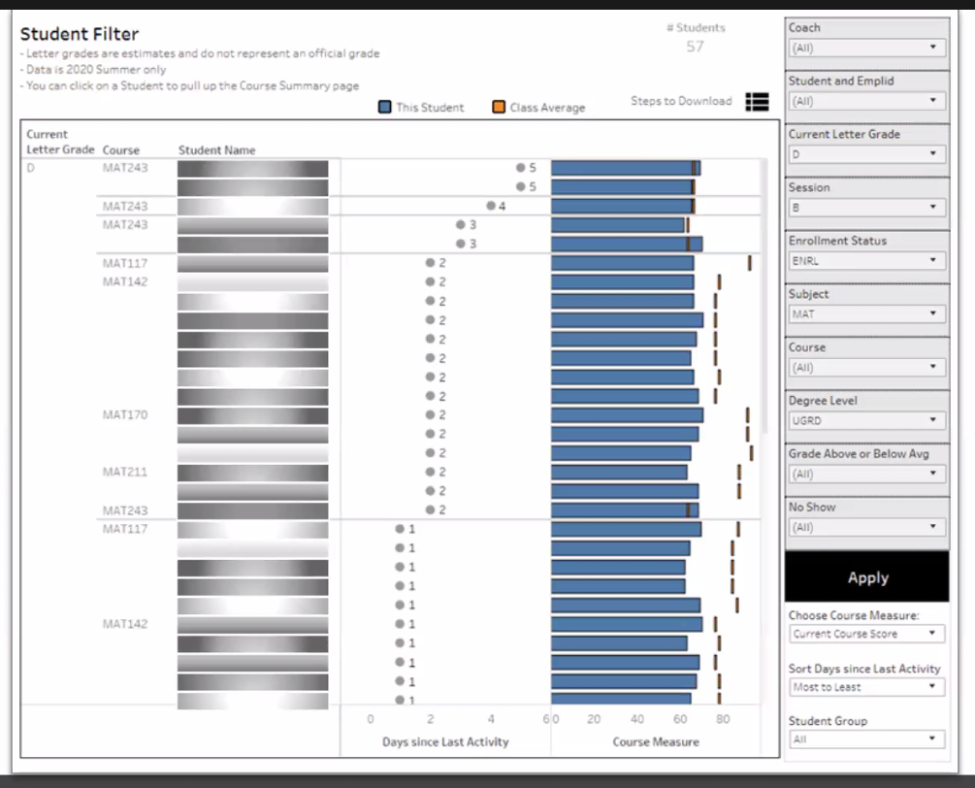

Other Course Measures: Current course score; days since last access; minutes; logins; clicks

Identification of ‘at risk’ students left up to the ‘success coach’ who monitors the students. Training in the use of the dashboard managed by supporting the experts who then help the others.

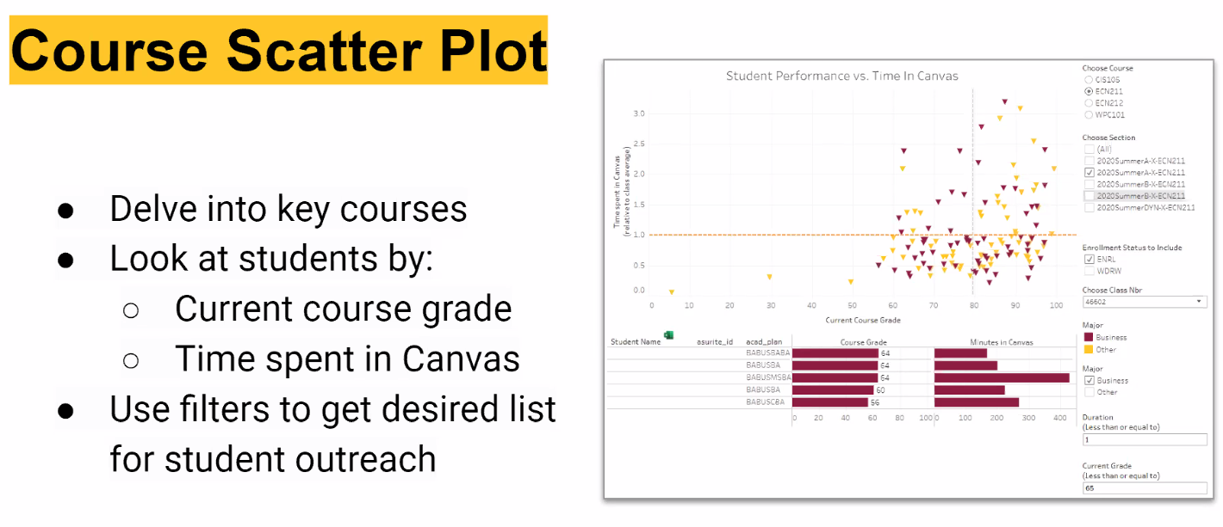

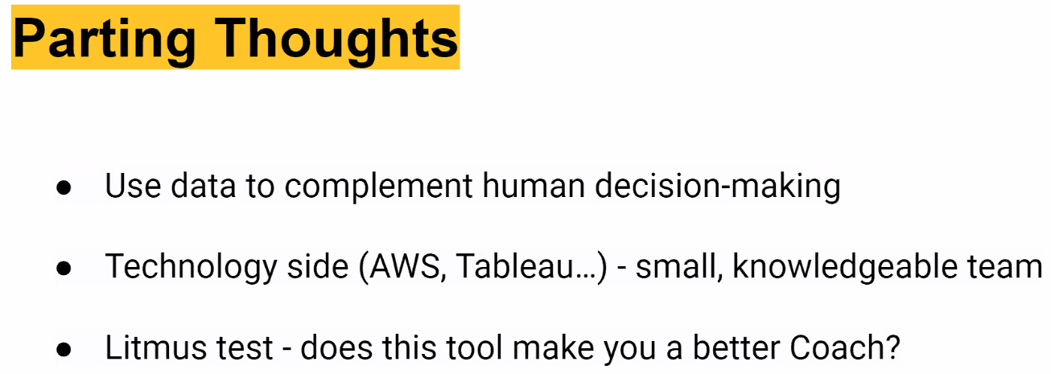

Note – this subject was an indicator subject – students who struggle in this subject will struggle in the rest of the program

*Other comments*

On efficacy of products – ask the people who use it (dashboards) “does this make you a better x?”. Sometimes showing causation and effect is too hard (sometimes they don’t even try).

The Faculty that want to support students don’t reach out (to the analyst)